[Note by Secretariat: This version is revised by the lead author based on referee’s comments]
DRAFT ANNEX to ISPM 27:2006 – Sorghum halepense (L.) Pers.
Status box (This is not an official part of the standard, and will be modified after adoption)
Date of this document | 2014-06-23
Document category | Draft annex to ISPM 27:2006 (Diagnostic protocols for regulated pests)
Current document stage | To TPDP meeting, June 2014
Origin | Work programme topic: The draft DPs on Sorghum halepense  Original subject: The draft DPs on Sorghum halepense
Major stages | 2012-11 First draft presented to TPDP (meeting)  2013-06 Expert consultation (IPP)  2014-01 Expert consultation
Consultation on technical level | The first draft of this diagnostic protocol was prepared by (lead author and editorial team):  - Mr. Sheng Qiang (Professor, Weed Research Laboratory, Nanjing Agricultural University, China)  - Mr. Rodney W. Young(National Identification Services, Plant Safeguarding and Pest Identification, USDA, USA)  - Mr. Ahmet Uludag (Igdir University, Igdir, Turkey)  The draft, in whole or part, has also been commented upon by:  - Ms. Liping Ying(Professor, Shanghai Quarantine and Inspection Department, China)  - Mr. Guoqi Chen (Weed Research Laboratory, Nanjing Agricultural University, China)  - Mr. Fuxiang Wang,(Senior Research Scientist, Agricultural Technology Extension Centre, The Ministry of Agriculture, China)  - Mr. Yonghong Zhou, (Professor, College of Life Science, Sichuan Agricultural University, China)  - Ms. Jianqiu Zou, (Senior Research Scientist, Liaoning Academy of Agriculture Science, China)  - Ms. Xiuling Shao (Professor, College of Plant Protection, Southern China Agricultural University, China)
Main discussion points during development of the diagnostic protocol | - Remove general elements that relate to sampling for inspection and not to sampling for the laboratory. The sampling size for sampling of consignments is not relevant in the protocol. The protocol should describe what is required for the test, the quantity of material and the steps to obtain it, but it should not go into earlier steps of sampling for inspection, etc.  - On site sampling should be mentioned only for seeds. The detection section should address detection of seeds.  - Remove elements that relate to inspectors and not to sampling for the laboratory. Sampling for inspection should not be in the protocol. The sampling size for sampling of consignments is not relevant in the protocol.  - Add a flow diagram. The text and flow diagram should be in line. The text should indicate the advantages of the methods described, in the section on identification.  - Text should give guidance on the advantages of the different methods, and should give a flow diagram.  - Keep information on the morphology of the six species for seed.  - Reproducibility, sensitivity and specificity are mentioned under 4.3. Data, whether qualitative or quantitative, should be included if available.  - Molecular assays should be rewritten as text.  - The draft diagnostic protocol was revised to address the points above raised by the TPDP and during the expert consultation period.
Notes | This is a draft document.

Contents
1. Pest information 4
2. Taxonomic Information 4
3. Detection 4
3. 1. Preparing samples for laboratory analysis 5
3. 2. Sieve detection 5
4. Identification 5
4. 1. Morphological Identification 5
4.2 Molecular assays 7
4.2.1 Assays based on DNA marker 7
4.3 Biochemical identification: SDS-PAGE of seed prolamin 9
4.4 Morphological identification of plants of Sorghum halepense 10
5. Records 11
6. Contact points for further information 11
7. Acknowledgements 12
8. Reference 12
9. Figures 14

1. Pest information
- Sorghum halepense (Johnsongrass) is a perennial grass with a ribbed leaf sheath, conspicuous midrib, large, purplish panicles, and extensively creeping rhizomes (Figure 1). It originated from hybridization of S. arundinaceum and S. propinquum through chromosome doubling (chromosome: 2n = 4x = 40). S. halepense, native to the Mediterranean area, is one of the world’s worst weeds, causing problems in more than 30 crop and fruit species (Holm et al. 1977). It threatens biodiversity in invaded habitats in no less than 50 countries in temperate and tropical areas throughout the world, including countries where it is a native species (Holm et al., 1977).
- S. halepense is distributed from latitude 55°N to 45°S, and it is best adapted to warm, humid, summer rainfall areas, high water table areas or irrigated fields in the sub-tropic zones. The striking invasiveness and tenacity of S. halepense is due to: 1) high reproductive capacity. S. halepense is able to reproduce by rhizomes or seeds. Fragments of its long, vigorous and highly adaptable rhizome system readily sprout and can be distributed by tillage. An individual S. halepense plant is able to produce as many as 28 000 seeds in a growing season. These seeds are able to survive and germinate under various environmental conditions. Seed reproduction may generate diverse ecotypes which distinctly differ in morphology, anatomy and physiology; [possibly 2 and 3 not related to invasiveness and tenacity. Consider separating] 2) being an alternate host of various pathogen species; 3) having allelopathic effects and toxicity to livestock (da Nobrega et al., 2006); 4) developing resistance to wide range of herbicide groups (HRAC, 2011); and 5) crossing with related species readily, which may produce more invasive hybrids and cause gene pollution of crop species (Arriola and Ellstrand, 1996).
- Seeds are the main means of spread of S. halepense (Figure 1), and are readily distributed by wind, water, birds and other animals. More importantly, the seeds are frequently disseminated as a contaminant of commodities traded around the world, in particular, crop seeds and raw grains, such as Sorghum bicolor (sorghum), Glycine max (soybean), Zea mays (maize), Triticum aestivum(wheat), Sesamum indicum(sesame), forage and Gossypium sp.(cotton) as well as bird seed mixes. Therefore, as the key for its control, seed detection and identification should be the core task in S. halepense quarantine.

2. Taxonomic Information
- Name: Sorghum halepense (L.) Pers. 1805
- Synonyms: Holcus halepensis L., 1753
Sorghum miliaceum (Roxb.) Snowden, 1955
Andropogon miliaceus Roxb., 1820
Sorghum controversum (Steud.) Snowden, 1955
Andropogon controversus Steud., 1854
- Taxonomic position: Plantae, Angiospermae, Poales, Poaceae
- Common name in English: Johnson grass

3. Detection
- Common survey methods of herbaceous species could be adopted for the detection of S. halepense in the field. Seed contamination of commodities such as crop seeds and grains is the most important factor in the distant dispersal of S. halepense. In order to detect seeds of S. halepense in crop seeds, an inspection procedure should be followed, by which a composite sample generally no less than 1 kg should be prepared for laboratory analysis and sieve detection. Although there have been seed detection procedures for some crops in some countries, it is required that a method can be used mainly to detect S. halepense seeds.

3. 1. Preparing samples for laboratory analysis
- General guidance on sampling methodologies is described in ISPM 31:2008 (Methodologies for sampling of consignments).The sample for examination should weigh approximately 1 kg. The remaining material should be labeled and conserved in dry paper bags or glassware.

3. 2. Sieve detection
- Assemble a set of sieves with different aperture sizes from 2 mm to 10 mm according to the seeds or grains sampled. The largest aperture sieve should be put on top on the bottom, in turn, smaller ones; put the sample selected into the top sieve, cover the sieve set and sieve. After sieving, collect the weed seed samples from each layer. Place the weed seed samples from each layer onto white plates for visual examination (ISPM 31:2008). Pick the weed seed like Fig.1 or suspected seed fragment up for further identification.

4. Identification
- Since detection of seed contamination of seed or grain shipments is the main concern with the quarantine of S. halepense, the present protocol focuses on seed identification using different methods.
- Identification of S. halepense is usually based on morphology. For suspect seeds with intact glumes and the upper lemmas, morphological methods are reliable (section 4.1). However, sometimes the fruits and seeds collected may be incomplete and parts of characters are unclear. In such cases molecular methods could be applied (section 4.2). Seeds may also be sown and the plants examined for taxonomic traits. See the flow diagram in Figure 4.

4. 1. Morphological Identification
- Morphological identification is a technique with the greatest importance.
- Generally, S. halepense is prone to be confused with five relative species in genus Sorghum: S. almum, S. propinquum, S. sudansense, S. bicolour, and silk sorghum a hybrid between Krish hybrid sorghum (Sorghum halepense x S. roxburghii) and S. arundinaceum. Thus, the present protocol compares S. halepense with the above five similar species. The detailed description of plant structure for S. halepense is described in Holm et al. (1997) and Flora of China Editorial Committee (2013). For silk sorghum information is provided in Ross (1999), and for S. almum, S. sudansense, S. bicolour and S. propinguum in Flora of China Editorial Committee (2013).

4.1.1 Morphological identification of seed of Sorghum halepense
- Caryopsis of S. halepense: brown, obovate, 2.6-3.2 mm in length and 1.5-1.8 mm in width; obtuse in the apex with persistent style; hilum rotund, deep purple brown; ventral side flat; embryo oval or obovate, with length about one-third to one half of the caryopsis (Figure 1 and 2).
Comparisons with similar species
- S. halepense seeds can be identified, in particular, based on characteristics of the glume and the second lemma (Table 1 and 2). A key for species identification can be used in case that a sampling seed is not easily matched to the characteristics description in the table.
- Table 1. Comparisons on the characters of sessile spikelet, caryopsis and seed mass among the six Sorghum species (based on Flora of China Editorial Committee,2013; Holm et al.,1977; Qiang, 2009; Sun et al., 2002 )

Species | Sessile spikelet | Caryopsis | 1000-seed  weight (g)
S. halepense | Oval, (3.8) 4-5 (5.6) mm in length, shortly pubescent | Dark brown, obovate, 2.6 – 3.2 mm in length and 1.5-1.8 mm in width | ≈ 4.9
S. propinquum | Oval or narrow oval, 3.8-4.5 mm in length, bearded | Brown, broadly ovate or broadly oval, about 2 mm in length and 1.5 mm in width | ≈ 3.8
S. almum | Oval or long oval, 4.5-6 mm in length, shortly pubescent | Broadly ovate or oval, red brown, 3.3 – 4 mm in length and 2-2.3 mm in width | ≈ 6.6
Silk sorghum hybrid | Oval, about 3.8 mm in length, shortly pubescent | Broadly ovate, yellow or yellow-brown, 2.5 – 4 mm in length and 1.7-2.5mm in width | ≈ 4.2
S. sudanense | Oval, (5-) 6 – 8 mm in length, sparsely pubescent | Broadly ovate, red-brown, 3.5 - 4.5mm in length, 2.5 - 2.8mm in width | 10-15
S. bicolor | Broad oval or ovate, (3-) 4.5 - 6 (-9) mm in length, hispid | Ovate, pink to red brown, 3.5-4mm in length, 2.5-3mm in width | >20g

- Table 2. Comparisons on the glume and upper lemma of seeds among the six Sorghum species
 | Glume | Lower glume | Upper glume | Upper lemma
S. halepense | Leathery, tawny, red brown, or purple black | Apex clearly 3-denticulate, 5-7-veined, dorsum ciliary but the rest glabrous | 3 -veined | Triangular lanceolate, apex 2-lobed and awned or not; awn 10–16mm
S. propinquum | Subleathery, dark brown with inconspicuous  crossveins | 9-11-veined, apex acute to apiculate or tridenticulate, pubescent | 7- veined | Lanceolate, about 3.5mm in length, acute or emarginate, awnless
S. almum | Chartaceous or subleathery, dark brown | Apex little 3-denticulate, 5-7-veined, dorsum ciliary but the rest glabrous | 3- veined | Lanceolate, apex obtuse or slightly acute with 2-lobed, awned, awn about 15mm
Silk sorghum hybrid | Leathery, tawny, red-brown or purple black | Apex little 3-denticulate, 5–7 veined, dorsum ciliary but the rest pubescent | 3-veined | Broad lanceolate, apex slightly 2-lobed, awnless
S. sudanense | Leathery, lemon yellow to red brown | Apex 2-denticulate, 11-13-veined, usually with crossveins, dorsum shortly ciliary. | 5-7-veined, with crossveins | Ovate or oval, apex 2-lobed, awned, awn 10-16mm
S. bicolor | Leathery, pink to red brown | Apex acute or 3-denticulate, 12-16-veinedwith crossveins, dorsum densely ciliary | 7-9-veined | Lanceolate to long oval, 2-4-veined, apex 2-lobed, awned, awn about 1mm

- The following key can also be used to discriminate the six different Sorghum species.
Keys for seed morphology of the six relative species (according to Flora of China Editorial Committee, 2013; Holm et al. 1977, Qiang, 2009 ):
1a. Glume with clear crossveins; lower glume with veins more than 11; large seed (1000-seed weight > 10g).
2a. Lower glume 11-13-veined with veins extending to the base; upper glume 5-7-veined with clear ridge……………………………………………… S. sudanense
2b. Lower glume 12-16-veined with veins unclear on the lower part; upper glume 7-9-veined with inconspicuous ridge near the top...................................... S. bicolor
1b. Glume with no clear crossveins; lower glume with 11 or fewer veins; small seed (1000-seed weight < 8g).
3a. Lower glume 9-11-veined…………….…………..…………..….. S. propinquum
3b. Lower glume 5-7-veined.
4a. Glume chartaceous or subleathery; upper lemma lanceolate, persistent rachilla rough in the fracture……………….….……….…………….…………. S. almum
4b. Glume leathery, upper lemma broad lanceolate or triangular lanceolate, persistent rachilla neat in the fracture.
5a.Lower glume with blurry 3-denticulate apex; upper lemma broadly lanceolate…………………………………………………………….Silk sorghum
5b.Lower glume with distinctly 3-denticulate apex; upper lemma triangular lanceolate….……………………………………………..…………. S. halepense

4.2 Molecular assays
- Three molecular assays (two based on DNA marker and one on seed prolamin) have been referred to support or verify a morphological identification of seeds of S. halepense in case of uncertainty of visible morphological identification. Molecular methods are generally more sensitive, and also could be important to assist visible discrimination of the seeds, in particular, for identifying partial seeds. For identification, at least about 0.05g seeds are needed.

4.2.1 Assays based on DNA marker
- DNA may be extracted from seed samples. For each of the assays described below refer to the source paper for the original specific DNA extraction technique used. Laboratories may find that alternative extraction techniques work equally well. Nevertheless, method described by Moller et al. (1992) is recommended for DNA microextraction from seeds of Sorghum species.
4.2.1.1 Inter-simple sequence repeat (ISSR)
- The method of Fang et al. (2008) was evaluated for discriminating six Sorghum species, and the samples they used were from China (S. saccharatum), USA (hybrid sorghum, S. sudanese and johnsongrass), Afghanistan (S. bicolor) and Australia (S. almum).
- The PCR primers used in this assay followed Fang et al. (2008):
IR89 (5’-VBVATATATATATATAT-3’)
IS16 (5’- AGAGAGAGAGAGAGACC-3’).
- Reactions are carried out in a volume of 20 µL ddH₂O solution containing 1×PCR buffer, 2.0 mM MgCl₂, 250 µM dNTP, 400 nM primer, 30 ng DNA template, 1.5 U Taq polymerase. ISSR-PCR reaction starts with 12 min at 94˚C, followed by 40 cycles of 30 second at 94˚C, 30 second at 48˚C, 1 min at 72˚C, and ended with 12 min at 72˚C. The PCR products are analyzed by gel electrophoresis.The IR89 primer produces 1500 base pair (bp) and 100 bp amplicons, and the IS16 primer produces 1200 bp, 1100 bp, 850 bp and 400 bp amplicons. Among these bands, S. halepense only has a band of 1500 bp; S. almum has bands of 1500 bp and 400 bp; S. bicolor has bands of 1200 bp, 1100 bp, 400 bp and 100 bp; hybrid sorghum (S. bicolor × S. sudanese) has bands of 1200 bp, 1100 bp, 400 bp, 850 bp and 100 bp; S. saccharatum has bands of 1200 bp, 400 bp and 100 bp; S. sudanese has bands of 400 bp and 100 bp.
4.2.1.2 SCAR (Sequence Characterized Amplified Regions)
- The method of Zhang et al. (2013) was evaluated for discriminating different Sorghum species. The S. halepense samples used were from USA, China, Argentina and Australia; the S. almum samples from USA, Argentina, Australia and Ethiopia; the S. bicolor from Argentina, Brazil, France, USA, China and two from unknown area; the S. vulgare and S. verticilliflorum samples from unknown area; S. saccharatum samples from China and three from unknown area; S. nitidum samples from Australia and China; S. arundinaceum from Australia; S. drummondii samples from Ethiopia, Kenya, Portugal and Zaire; S. sudanse samples from China and Argentina; the silk sorghum sample from Australia; and S. propinum samples from China.
- The PCR primers used in this assay are (Zhang et al.,2013):
SH1 (5’-AGATTGAGTCTCAGGTGC-3’)
SH2 (5’-GAGTCTCAGGGTATGATCT-3’).

- SCAR-PCR amplification: Each amplification reaction of 20 μl contained 2 μL 10 × PCR buffer, 0.4 mM Mix-dNTP, 0.25 mM of primer, one unit of Taq DNA polymerase and 25 ng of DNA. The thermocycler was programmed for 35 cycles: 30 s at 94°C, 40 s at 55°C, and 80 s at 72°C. The PCR products are analyzed by gel electrophoresis. The specific primers produce specific band of 500bp, which could be found in S. halepense samples and some S. almum samples from Australia, while S. nitidum, S. propinum, S. sudanense, S. bicolor, Silk Sorghum S. vulgare, S. saccharatum, S. arundinaceum, S. verticilliflorum, S. drummondii and S. sudanse produce no bands.
4.2.2 Controls for molecular tests
- For a reliable test result to be obtained the following controls should be considered for each series of nucleic acid isolations, amplification of the target pest or target nucleic acid depending on the test used and the level of certainty required. As a minimum, for ISSR and SCAR the positive extraction control and negative amplification control (no template control) should be used.
Positive nucleic acid control
- This is used to monitor the efficiency of the test method (apart from the extraction and the amplification). Genomic DNA of S. halepense may be used.
Internal control
- For ISSR and SCAR, plant internal controls matK-trnK should be incorporated into the protocols to eliminate the possibility of PCR false negatives due to extraction failure, nucleic acid degradation or the presence of PCR inhibitors. Preferably the internal control primers should be used CP3 5’-ACGAATTCATGGTCCGGTGAAGTGTTCG-3’), CP4 5’-TAGAATTCCCCGGTTCGCTCGCCGTAC-3’.The length of the PCR product is 750bp.
- When the internal control matK-trnK is not mentioned in the description of a PCR method, the laboratory should choose an internal control and validate it.
Negative amplification control (no template control)
- This is necessary with conventional and real-time RT-PCR to rule out false positives due to contamination during the preparation of the reaction mix. PCR grade water that was used to prepare the reaction mix is added at the amplification stage.
Positive extraction control
- This is used to ensure that nucleic acid from the target is of sufficient quantity and quality and that the target is detected. Nucleic acid is extracted from infected host tissue or healthy plant tissue that has been spiked with the target.
- The positive control should be approximately 1/10 of the amount of DNA extracted. A validated S. halepense -positive nucleic acid control may be used to ensure the validity of the identification.
- For PCR, care needs to be taken to avoid cross contamination due to aerosols from the positive control or from positive samples. The positive control used in the lab should be sequenced so that this sequence can be readily compared to sequence obtained from PCR amplicons of the correct size. Alternatively, synthetic positive controls can be made with a known sequence which again can be compared to PCR amplicons of the correct size.
Negative extraction control
- This is used to monitor contamination during nucleic acid extraction and/or cross-reactions with the host tissue. This requires nucleic acid extraction and subsequent amplification of uninfected host tissue. It is recommended to include multiple controls when large numbers of positives are expected.

4.3 Biochemical identification: SDS-PAGE of seed prolamin
- The method of Fang et al. (2007) was used to identify S. halepense from its similar species such as S. bicolour, S. sudanense and S. almum, which could be one of alternative method for relative identification.
- Seeds are prepared for a test: for each sample, 30 mature and plump seeds (at least 10 seeds); grind into fine powder, in which 0.1 g powder is transferred into a 1.5 mL microtube.
- Add n-propanol, glycol, isopropanol and tertbutanol (all with concentration of 60 % mass fraction) 600 μL, respectively; 10 hours water bath at 37 °C, centrifuge the tube at 8000 rpm for 15 min. Transfer all of the supernatant liquid into a clean tube and store under 4°C.
- Take 500 μL extract of prolamin into a tube, add 500 μL pre-colded acetone, then keep under 4°C for 10 min, and centrifuge the tube at 8000 rpm for 15 min. Aspirate off supernatant, dry at room temperature, add 100 μL buffer (contain 6 mol/L Urea, 30% Glycerin, and 25mmol/L Acetic acid).
- Prolamin samples with 25μg are resolved by electrophoresis on 15% polyacrylamide slab gels. Proteins are stained with Coomassie brilliant blue G250. The electrophoretic buffer is acetic acid-glycine solution (pH 3.2-3.5). The gels are then prerun with 150 V for 4.5 hours. Then the bands are analyzed with a gel imaging system. The prolamins from seeds of different species by A-PAGE showed different numbers of bands in different areas as:
- S. halepense only shows one band in γ area; S. bicolor shows three bands in α area, one in β area and two in γ area; hybrid sorghum (S. sudanense × S. bicolor) shows two bands in β area and two in γ area; S. sudanense shows two in γ area; while S. almum shows no band in the three areas.

4.4 Morphological identification of plants of Sorghum halepense
- Seeds can be grown to plants for identification and rhizomes can be a factor for identification. Seeds are incubated for 7 days on moistened filter papers in petri dishes (9 mm in diameter) with a 12 h photoperiod at 25°C. Seedlings with roots and leaves are transplanted into 10-cm-diam plastic pots containing sterilized soil mix in 1:1:1 sand, soil and peat. Seedling-transplanted pots are placed in a greenhouse with 28/20 C day/night temperatures, natural light. Many Flora or other books related to plants or weeds may be used to identify the family Poaceae, genus Sorghum, and S. halepense. In this text the characters used to identify S. halepense are from Flora of China Editorial Committee (2013) and Holm et al. (1977). Figures 2 and 3 show the morphological attributes of S. halepense. Additional photos are available at the USDA website (http://plants.usda.gov/java/profile?symbol=SOHA) .
- Vegetation: perennial with vigorous, spreading rhizomes. Culms 0.5-1.5 (-2.0) m tall, 4-6 (-20) mm in diameter; nodes puberulous. Leaf sheaths glabrous; leaf blades linear or linear-lanceolate, (10-) 25-80 (-90) × (0.8-) 1-4 cm, glabrous; ligule 0.5-1 (2-6) mm, glabrous ciliate (Figures 2 and 3).
- Inflorescence: panicle lanceolate to pyramidal in outline, (10-) 20-40 (-50) cm, soft white hairs in basal axil; primary branches solitary or whorled, spreading, lower part bare, upper part branched, the secondary branches tipped by racemes; racemes fragile, composed of (1-) 2-5 spikelet pairs (Figure 2, Figure 3).
- Spikelet: usually in pairs although toward the tip of the inflorescence they may occur in threes; when the spikelet is in pairs, the lower is sessile and perfect with the upper pedicelled, narrow, long, and stamen-bearing; when spikelets in threes, one is sessile and perfect, the others are pedicelled and staminate. Sessile spikelet elliptic, (3.8-) 4-5 (-6.5) mm; callus obtuse, bearded; lower glume leathery, often pale yellow or yellowish brown at maturity, shortly pubescent or glabrescent, 5-7-veined, veins distinct in upper part, apex 3-denticulate; upper lemma acute and mucronate or 2-lobed and awned or not; awn 1-1.6 cm. Pedicelled spikelet staminate, narrowly lanceolate, (3.6-) 4.5-7 mm, often violet-purple (Figure 2, Figure 3).
- Seedling: cotyledon about 13 mm, primary leaves linear with 28 mm×3 mm; hypocotyl 16-18 mm in length and epicotyl 4-6 mm (Guo & Huang, 1992). It can be used to discriminate as early stage of plant growth as possible.
- The following key can be used to discriminate plant individuals of S. halepense from the five similar Sorghum species.
- Plant keys:
- Based on morphological characteristics of vegetative organs (Flora of China Editorial Committee, 2013; Kang et al, 2000; Sun et al., 2002.)
1a. Annual, without rhizome; usually cultivated or occasionally wild.
2a. Culm base 20-50 mm in diameter……………………........................…..S. bicolor
2b. Culm base 3-9 mm in diameter………………….......……………… S. sudanense
1b.Perennial, developed rhizome; usually wild or occasionally cultivated.
3a. Rhizome thick and short.
4a. Culm base 10-30 mm in diameter, node with grey white shortly pubescent, liguleless with clear hair in the apex.....................................................S. propinquum
4b. Culm base thiner than 10 mm, node glabrous, liguleless without clear hair in the apex…………………….......................................................................…. S. almum
3b. Rhizome thin and developed.
5a. Culm robust with base about 10mm in diameter, thicker than rhizome, leaf with richome or shell-like trace on the epidermis…………………………Silk sorghum
5b. Culm fragile with base 4-6mm in diameter, thinner than rhizome, leaf glabrous……………………………………………………………… S. halepense
Based on morphological characteristics of reproductive organs (Flora of China Editorial Committee, 2013)
1a. Racemes robust and not easily fractured ….........................................S. bicolor
1b. Racemes fragile.
2a. Pedicelled spikelet persistent.
3a. Panicle 30-50 cm long Panicle dark magenta, caryopsis deep red brown….......................................................................................………. S. almum.
3b. Panicle 15-30 cm long.………………………………………… … S. sudanense
2b. Pedicelled spikelet deciduous.
4a. Racemes loosely arranged……………………………….....…………Silk sorghum
4b. Racemes tightly arranged.
5a. Panicle ovate, sessile spikelet ovate................................................S. propinquum
5b. Panicle lanceolate, sessile spikelet elliptic………………………. S. halepense

5. Records
- Records and evidence should be retained as described in section 2.5 of ISPM 27:2006. In cases where other contracting parties may be adversely affected by results of the diagnosis, the records and evidence should be kept for at least one year.

6. Contact points for further information
- Further information on this protocol can be obtained from:
Weed Research Laboratory, Nanjing Agricultural University, Nanjing China, 210095, (Dr. Sheng Qiang, e-mail: qiangs@njau.edu.cn, wrl@njau.edu.cn, Phone & Fax: +86 25 84395117).
National Identification Services, Plant Safeguarding and Pest Identification, USDA, APHIS, PPQ, Seed Examination Facility, Building 308, Room 319, BARC-East, Beltsville, MD 20705, (Dr. Rodney W. Young, e-mail: rodney.w.young@aphis.usda.gov, Phone: 1 (301) 313-9333, FAX: 1 301 504-9840).
Department of Plant Protection, Faculty of Agriculture, Igdir University, Igdir, Turkey. (Ahmet Uludag, e-mail: ahuludag@yahoo.com, Phone: cell 90 537 578 1211) .
Further information on suspected seed identification may alternatively go to: CFIA’s Seed Science and Technology Section.
A request for a revision to a diagnostic protocol may be submitted by NPPOs, RPPOs or CPM subsidiary bodies through the IPPC Secretariat (ippc@fao.org), which will in turn forward it to the TPDP.

7. Acknowledgements
- The first draft of this protocol was written by Sheng Qiang, Guoqi Chen and Hongjie Xie(see preceding section), Rodney W. Young (see preceding section), Ahmet Uludag (see preceding section). The group of the scientists including Dr. Fuxiang Wang, Prof. Yonghong Zhou, Dr. Jianping Zou, Dr. Liping Ying, Dr. Xiuling Shao reviewed the manuscript and made comments to improve it.

8. Reference
Arriola, P.E. & Ellstrand, N.C. 1996. Crop-to-weed gene flow in the genus Sorghum (Poaceae): Spontaneous interspecific hybridization between johnsongrass, Sorghum halepense, and crop sorghum, S-bicolor. American Journal of Botany, 83:1153-1159.
da Nobrega, J.E., Riet-Correa, F., Medeiros, R.M.T. & Dantas, A.F.M. 2006. Poisoning by Sorghum halepense (Poaceae) in cattle in the Brazilian semiarid. Pesquisa Veterinaria Brasileira, 26: 201-204.
Fang, X. E., Chen, Q., Yin, L. P., Ding, J.B. & Wang, W. 2007. A-PAGE establishment in genus Sorghum and its application for seed identification. Xibei Zhiwu Xuebao, 27: 2399-2403. [in Chinese]
Fang, X.E., Chen, Q. Yin, L. P. & Wang, W. 2008. Application of ISSR in genetic relationship analysis of Sorghum species. Acta Agronomica Sinica, 34: 1480-1483.
Flora of China. URL: http://www.efloras.org/florataxon.aspx?flora_id=2&taxon_id=242414381 Accessed 29 May, 2014.
Flora of China Editorial Committee, Flora of China,10(2), Beijing: Science Press, 1997 [in Chinese]
Guo, Q.X. & Huang, K.H. 1992. Identification of seedlings of Sorghum halepense and its relative speceis. Zhi Wu Jian Yi, 6: 333-334. [in Chinese]
Holm, L.G., Plucknett, D.L., Pancho, J.V. & Herberger, J.P. 1977. The world's worst weeds: distribution and biology. Honolulu, USA, University Press of Hawaii. pp 54-61.
HRAC 2011. International survey of herbicide resistant weeds. URL: http://www.weedscience.org/In.asp. Accessed 22 Mar 2011.
ISPM 31. 2008. Methodologies for sampling of consignments. Rome, IPPC, FAO.
Kang, L., Huang, P.Q., Zhu, X.Q., Zhou, P.H. & Liu, R.S. 2000. Plant Quarantine, 14: 274-275.
Moller, E., Bahnweg, G., Sandermann, H. & Geiger, H. 1992. A simple and efficient protocol for isolation of high molecular weight DNA from filamentous fungi, fruit bodies, and infected plant tissues. Nucleic Acids Res., 20: 6115-6116.
Qiang, S. 2009. Weed Science. Beijing: China Agriculture Press House, ISBN 978-7-109-13192-7, pp.119-120, 125-128. [in Chinese]
Ross, B.J. 1999. Silk sorghum. Agnote (Darwin),, 784:3
Sun, J.Y., Qiang, S., Diao, C.X. & Yin, L.P. 2002. A Study on comparative anatomy of Silk Sorghum and quarantine weed johnsongrass (Sorghum halepense). Acta Agriculturae Universitatis Jiangxiensis, 16: 840-846. [in Chinese]
USDA. URL: http://plants.usda.gov/gallery/pubs/soha_021_php.jpg. Accessed 21 June 2013.
Zhang, W.J., Wei, S.S., Yin, L.P., Deng, Z.H., Yi, J. P., Wu, R.Q., & Chen, Q. 2013. RAPD Marker conversion into a SCAR marker for rapid identification of Johnsongrass [Sorghum halepense (L.) Pers.]. Notulae Botanicae Horti Agrobotanici Cluj-Napoca, 41:306-312.
.

9. Figures
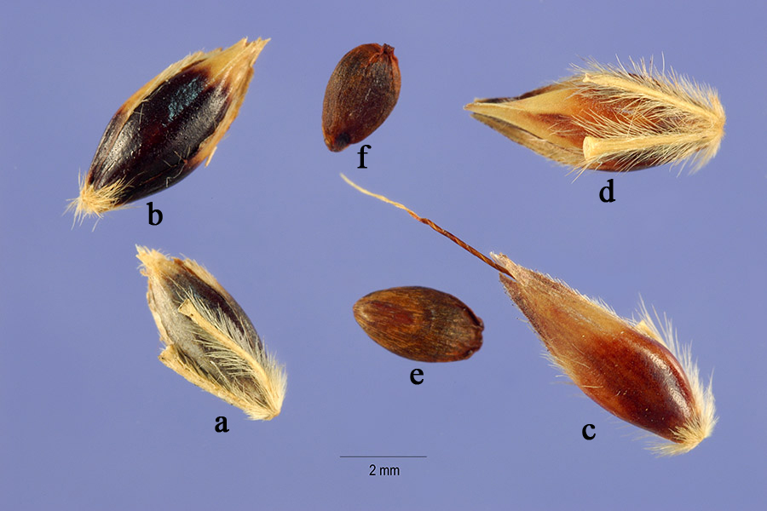
Figure 1. Spikelets and caryopses of Sorghum halepense (Source: USDA, 2013).
a & d. adaxial view of sessile spikelet with residual rachilla; b. abaxial view of sessile spikelet; c. abaxial view of sessile spikelet with awn; e. abaxial view of caryopsis; f. adaxial view of caryopsis

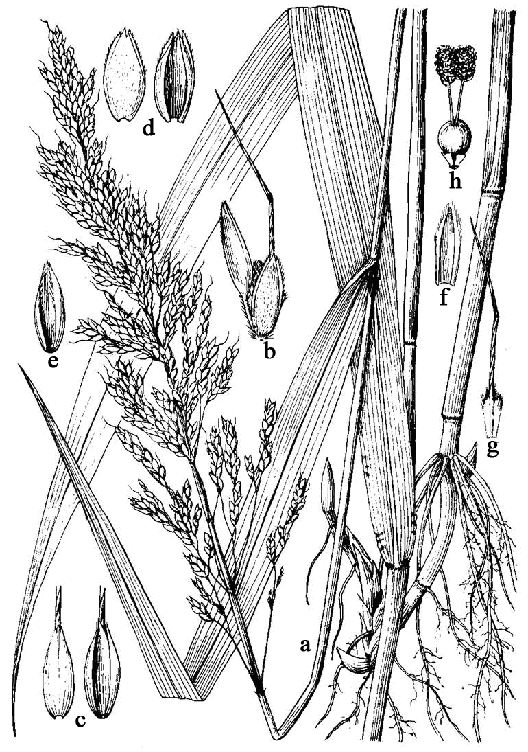
Figure 2. Plant parts of S. halepense (Sorghum halepense). a: plant, b: spikelet; c: abaxial and adaxial views of sessile spikelet; d: lower glume of sessile spikelet; e: upper glume of sessile spikelet; f: lower lemma of sessile spikelet; g: upper lemma of sessile spikelet; h: lodicules and pistil (Source: Flora of China Editorial Committee, 1997).
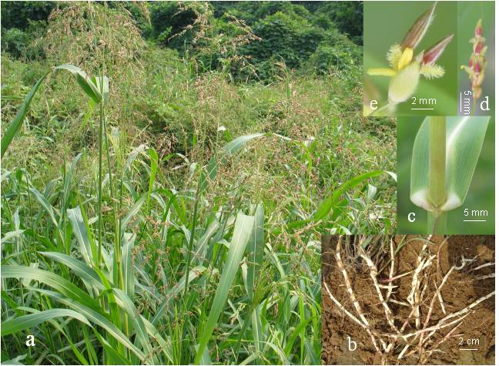
Figure 3. Morphological characteristics of Sorghum halepense (Source: Sheng Qiang).
a. above ground parts, b. rhizome, c. sheath mouth, d. part of panicle, e. perfect spikelet with two pedicelled, staminate spikelets.

Identify seedlings based on Section 4.4 Seedling
Sow suspected weed seeds to grow into what?plants
Identify adult plants based on Section 4.4 Vegetation, Inflorescence and Spikelet
ISSR in Section 4.2.1
SCAR in Section 4.2.1

Identified as Sorghum halepense or not as S. halepense
Or
Not identified
Preparing weed seed samples like Sorghum halepense for identification
Morphological identification of above suspected weed seed based on Section 4.1.1
Identified as Sorghum halepense or not as S. halepense
Not identified
Molecular identification in Section 4.2
Biochemical identification in Section 4.3
Or
Or
Identified as Sorghum halepense or not as S. halepense

Figure 4. Flow diagram for identifying S. halepense.

