DRAFT ANNEX to ISPM 27: Fusarium moniliformis / moniliforme syn. F. circinatum (2006-021)
Status box
This is not an official part of the standard and it will be modified by the IPPC Secretariat after adoption.
Date of this document | 2015-05-26
Document category | Draft new annex to ISPM 27 (Diagnostic protocols for regulated pests)
Current document stage | To TPDP June 2015
Origin | Work programme topic: Fungi and fungus-like organisms, CPM-1 (2006)  Original subject: Gibberella circinata
Major stages | 2006-05: SC added original subject: Gibberella circinata (2006-021)  2015-03 Expert Consultation
Discipline leads history | Hans de Gruyter (NL, Discipline Lead)  Robert TAYLOR (NZ, Referee)
Consultation on technical level | The first draft of this diagnostic protocol was written by:  - Ana Perez-Sierra, Alice Holt Lodge, Farnham, UK  - Renaud Ioos, ANSES, Malzéville, France  - Mónica Berbegal Martínez, Universidad Politécnica de Valencia, Valencia, Spain  In addition, the draft has also been subject to expert review and the following international experts submitted comments:  [To be completed]
Main discussion points during development of the diagnostic protocol | - It is agreed by the authors that the name Fusarium circinatum is used with Gibberella circinata as synonym, following Geiser et al., 2013.  - Is morphological identification reliable enough to consider the pathogen present or not?
Notes | This is a draft document.

CONTENTS [To be added later]
Adoption
- This diagnostic protocol was adopted by the Commission on Phytosanitary Measures in 20--.
- The annex is a prescriptive part of ISPM 27.

1. Pest Information
- Fusarium circinatum is an ascomycete fungus formerly described as an anamorph of Gibberella circinata (Geiser et al. 2013) and is the causal agent of pitch canker disease. The disease almost exclusively affects Pinus spp., but was also described on Douglas-fir (Pseudotsuga menziesii). This disease affects plantations and nurseries in several countries worldwide and is a serious threat to pine forests wherever it occurs (especially on Pinus radiata), due to extensive tree mortality, reduced growth and timber quality. Fusarium circinatum causes cankers that girdle branches, aerial roots, and even trunks of Pinus spp. Cankers are often associated with conspicuous and sometimes spectacular resin exudates (“pitch”). Multiple-branch infections may cause severe crown dieback and eventually lead to the death of the tree. This aggressive fungus may also cryptically infect the Pinus seeds and may cause damping-off in seedlings in nurseries. The fungus has been found in regions of North, Central and South America, Asia and South Africa and has been officially reported in parts of Southern Europe. The distribution of the pathogen is available at EPPO Global Database (2014) and on the CABI website (2015), and updated on a regular basis.
- Fusarium circinatum is predominantly a wound pathogen and enters the host tree through mechanical wounds or feeding holes caused by wood-boring insects. If a wound is not deep enough for the pathogen to reach water within host tissues, ambient moisture or very high relative humidity is required for spore germination. Conidia of F. circinatum germinate over a wide range of temperatures; slowly at 10°C and progressively faster, up to an optimum, around 20°C (Inman et al. 2008). In nature F. circinatum is known to propagate only asexually, through production of microconidia and macroconidia. Both spore types are borne in a viscous liquid and appear better suited to dispersal by splashing water or attachment to motile organisms than aerial dispersal. However, both can become airborne and are presumably the primary propagules recovered by air sampling in areas where pitch canker is found (Correll et al. 1991). The fungus may move from tree to tree by aerial dispersion of the conidiospores or through vectoring by feeding insects (Gordon et al. 2001; Schweigkofler et al. 2004). However, long-range dispersal of the pathogen from affected areas to disease-free areas may be driven by infected seed movement and movement of infected plant material (Storer et al. 1998). Conifer seeds can be colonized by F. circinatum internally (where it can remain dormant until seed germination) and externally (Storer et al. 1998).
- Fusarium circinatum is also capable of producing perithecia, which contain meiotically derived spores (ascospores). However, perithecia have not been observed in nature, but are readily produced on culture media under laboratory conditions. At maturity, ascospores ooze out of the ostiole and, like mitospores, they appear unsuited to airborne dissemination.

2. Taxonomic Information
- Name: Fusarium circinatum Nirenberg & O´Donnell, 1998
- Synonyms:
- Fusarium moniliforme var. subglutinans Wollenw. & Reinking, 1925
- Gibberella fujikuroi var. subglutinans E.T. Edwards, 1933
- Fusarium lateritium f.sp. pini Hepting, 1949
- Fusarium subglutinans Wollenw. & Reinking) P.E. Nelson, Toussoun & Marasas, 1983
- Gibberella subglutinans (E.T. Edwards) P.E. Nelson, Toussoun & Marasas, 1983
- Fusarium subglutinans f.sp. pini J.C. Correll, T.R. Gordon, McCain, J.W. Fox, Koehler, D.L. Wood & M.E. Schultz, 1991
- Gibberella circinata Nirenberg & O'Donnell ex Britz, T.A. Cout., M.J. Wingf. & Marasas, 2002

- Mycobank MB 466034
- Taxonomic position: Eukaryota: Fungi: Dikarya: Ascomycota:Pezizomycotina:
Sordariomycetes: Hypocreomycetidae: Hypocreales: Nectriaceae.
- Common names: Pine pitch canker (English)

3. Detection

- Despite the fact that they may exhibit different susceptibility levels to F. circinatum, all the Pinus spp. along with Douglas-fir (Pseudotsuga menziesii), may be potentially affected by this fungus and the symptoms can be observed at any time of the year. Additionally, F. circinatum can affect different age plants ranging from seedlings to mature trees and it can be detected on all its parts (roots, branches, shoots, cones and seeds). Fusarium circinatum may also be soil-borne.

3.1 Symptoms on seedlings
- Infected seedlings show usual damping off symptoms, but are not distinctive: needles turn red, brown or chlorotic and die from the base upwards or the seedling dies (Figure 1). In some cases affected seedlings may show brown discoloration on roots and lower part of the stems. However, in some occasions, F. circinatum may infect seedlings cryptically, meaning that there are no obvious symptoms to be observed.

3.2 Symptoms on trees
- Symptoms on roots are brown discoloration and disintegration of the cortex and are similar to symptoms caused by other root rot pathogens. Consecutive above-ground symptoms are generally not apparent until the pathogen reaches the crown after it girdles the stem, causing yellowing of the foliage. Resin-soaked tissue may then be observed after removal of the bark on the lower part of the stem.
- Aerial infection symptoms include yellowing of the needles, which turn red in time and finally drop, and dieback of the shoots. Multiple branch tip dieback, due to repeated infections, may lead to a significant crown dieback. Cankers may thereafter appear on the shoots, on the main -branches and even on the trunk, associated with conspicuous and sometimes spectacular resin exudates (‘pitch’) in response to the fungal infection (Figure 2). The cankers can girdle branches and even trunks.
- However, the symptoms in older trees can be mistaken with those caused by Sphaeropsis sapinea (Fr.) Dyco & Sutton (synonym Diplodia pinea) or feeding damages caused by wood-boring insects, therefore the diagnosis should be based on testing. Sometimes, this resin bleeding may coat the trunk and lower branches for several meters below the infection level. The stem cankers are flat or slightly sunken and may sometimes affect large surfaces of cortical and subcortical tissue of the trunk. Removal of the bark shows subcortical lesions with brown and resin-impregnated tissues (Figure 3).
- The female cones on infected branches may also become affected and abort before reaching full size. However, depending on the timing and severity of infection, an infected cone may sometimes remain symptomless. Seeds can be infected cryptically (Storer et al. 1998).

4. Identification
- This protocol describes the detection and identification of F. circinatum on symptomatic plant tissue and on seeds. Plants and trees should be inspected for any symptoms typical of pine pitch canker (see section 3) whereas seed may be analysed by random sampling. Diagnostic Method A (isolation and culturing) and diagnostic Method B (molecular assays) may both be used for plant tissue and seeds.
- However, it is reported in the literature that F. circinatum may sometimes be present in a quiescent form which cannot be detected in seeds by isolation (Storer et al. 1998). Therefore, the absence of F. circinatum cannot be ascertained by isolation from seeds. On the other hand, non-viable propagules of F. circinatum may generate positive results using the molecular methods.
- For both Method A and Method B, due to the high diversity and complexity of the Fusarium genus, especially in the ‘Gibberella fujikuroi’ complex that F. circinatum formerly belonged to, diagnostic will sometimes have to be ascertained by an additional DNA sequence analysis step. The identity of F. circinatum can only be confirmed with certainty by applying the diagnostic method described below (Figure 4. Flow diagram).
- In this diagnostic protocol, methods (including reference to brand names) are described as published, as these define the original level of sensitivity, specificity and reproducibility achieved. The use of names of chemicals implies no approval of them to the exclusion of others that may also be suitable. Laboratory procedures presented in the protocols may be adjusted to the standards of individual laboratories, provided that they are adequately validated.

4.1 Sampling and sample preparation

4.1.1 Plant tissue (except seeds)
- Whole seedlings should be placed in sealed plastic bags and kept under cool conditions until they are sent to the laboratory. When received in the laboratory, the samples should be kept in a refrigerator until analysis preferably within 2 days.
- For trunk or branch cankers, the inner bark in the area directly around the visible lesion should be cut repeatedly with a sterile blade until a canker margin is observed. Pieces of tissue, including phloem and xylem, should be removed to collect portions of the lesion edge, where the fungus is most active. The pieces of tissue should be wrapped with sheets of paper and placed in a sealed plastic bag. All samples of plant material should be sent to the laboratory as soon as possible after sampling, and refrigerated until transfer. When received in the laboratory, the samples must be kept in a refrigerator to be analysed within 8 days.

4.1.2 Seeds
- As no symptoms can be observed on seeds, the lot should be sampled randomly. Depending on the method chosen for the identification, the number of seeds to be analysed per lot may be different. As counting of seeds may be laborious, the sampled seeds may be weighed instead of counted. The total number of seeds to be tested in order to detect the pathogen at different infection levels in a lot needs to be determined statistically (useful guidance is given in Tables 1 and 2 of ISPM 31: Methodologies for sampling of consignments (International Plant Protection Convention 2008)). Sample size recommended by ISTA is 400 seeds for plating (ISTA 2002). However, larger samples (e.g. 1000 seeds) can easily be processed by biological enrichment before DNA analyses (Ioos et al. 2009). The seeds will be subsequently analysed without any surface disinfection, as F. circinatum may be present on the seed husk, as well as inside the seed.
- Seeds may be analyzed by isolation and culturing or by conventional or real-time PCR after a biological enrichment step (see 4.3.1.2.). These different methods have been compared in the framework of a European collaborative study, and performance values have been calculated for each of them (Ioos et al. 2013) .

4.2. Method A: Isolation and culturing

4.2.1. Tissue except seeds
- Plant material should be surface-sterilized for 1 min in a 1.5% solution of sodium hypochlorite, and rinsed in sterile distilled water. It is recommended to use selective media for isolations, such as DCPA medium, Komada’s medium or Potato dextrose agar supplemented with 0.5 mg ⁄mL of streptomycin sulphate salt (775 units ⁄mg solid) (PDAS) (see section 4.2.3).
- On seedlings the pathogen is isolated from the lower part of the stem and/or from the roots. Roots and the lower part of the stem are washed thoroughly with water and isolations are made from the leading edge of the lesions. If no lesions are present, isolations are made from small fragments of roots or lower stems, selecting at random.
- On mature trees, isolations are made from cankers. The cankers are washed thoroughly with water, and isolations are made from wood-chips taken from the edge of the lesion found beneath the affected bark.
- Plates are incubated at room temperature (22 °C ± 6 °C). During incubation, the plates are observed daily and all the Fusarium spp. colonies are transferred to Potato dextrose agar (PDA) and to Spezieller-Nährstoffarmer Agar (SNA) for identification.

4.2.2. Seeds
- Seeds are directly plated onto Komada’s medium, DCPA medium or PDAS without previous surface disinfection. Plates are incubated at room temperature (22 °C ± 6°C). During incubation, the plates are observed daily and all the Fusarium spp. colonies are transferred to Potato dextrose agar (PDA) and to Spezieller-Nährstoffarmer Agar (SNA, (see section 4.2.3) for morphological identification. This method is efficient and reliable to isolate any Fusarium spp. from the seeds and does not require expensive equipment, though time- and space-consuming when serial analyses are conducted. However, it should be noted that Storer et al. (1998) have demonstrated that agar plating of pine seeds may not be able to detect dormant (quiescent) propagules of F. circinatum results. There are no published methods dealing with the isolation of F. cirninatum from soil.

4.2.3. Culture media
- Dichloran Chloramphenicol Peptone Agar (DCPA). This medium is suitable for isolation of Fusarium spp. from plant tissue, including seeds, but not for identification. The medium contains 15.0 g Bacteriological peptone, 1.0 g KH₂PO₄, 0.5 g MgSO₄(7H₂O), 0.2 g Chloramphenicol, 2 mg 2.6-dichloro-4-nitroanilin (dichloran) (0.2% W⁄V in ethanol, 1.0 mL), 0.0005 g Violet crystal (0.05%W/V in water, 1.0 mL), 20.0 g Technical agar in 1 L of distilled water (slightly modified by Ioos et al. (2004); after Andrews & Pitt (1986)).
- Komada medium. This medium is suitable for isolation of Fusarium spp. from plant tissue, including seeds, but not for identification. The basal medium contains 1.0 g of K₂HPO₄, 0.5 g KCl, 0.5 g MgSO₄ 7H₂O, 10 mg Fe-Na-EDTA, 2.0 g L-Asparagine, 20.0 g D-Galactose, 15.0 g Technical agar in 1.0 L of distilled water. The pH is adjusted to 3.8 ± 0.2 with 10% phosphoric acid. The basal medium is autoclaved at 121 °C for 15 min and slightly cooled before adding the following filter-sterilized supplemental solutions: 1.0g Pentachloronitrobenzene (PNCB, 75% w⁄/w), 0.5 g Oxgall, 1.0 g Na₂B₄O₇ 10H₂O, 6 mL/L of stock solution (5 g of streptomycin in 100 mL distilled water) Streptomycin (Komada 1975).
- Potato dextrose agar (PDA). PDA is commercially available. Alternatively, it can be prepared according to the method described by Hawksworth et al.(1995).
- Spezieller-Nährstoffarmer agar (SNA). This medium should be mandatory used for identification of Fusarium spp., based on morphological features. The medium contains: 1.0 g KH₂PO₄, 1.0 g KNO₃, 0.5 g MgSO₄ 7H₂O, 0.5 g KCl, 0.2 g Glucose, 0.2 g Sucrose, 20.0 g Technical agar in 1.0 L of distilled water. Optionally, one or two 1-cm² square pieces of sterile filter paper may be laid on the surface of the agar since Fusarium sporodochia are sometimes more likely to be produced at the edge of the paper (Gerlach, Nirenberg 1982).

4.2.4. Cultural characteristics
- To study colony morphology and pigmentation the isolates are grown on PDA and incubated at room temperature. Fusarium circinatum grows relatively rapidly (average growth of 4.7 mm / day at 20°C; (Nirenberg & O’Donnell 1998). After 10 days, the colony should have an entire margin, white cottony or off-white aerial mycelium with a salmon tinge in the middle or with a purple or dark violet pigment in the agar (Figure 5).

4.2.5. Morphology
- The isolates are grown on SNA to study formation and type of microconidia, macroconidia and conidiogenous cells. SNA plates are incubated at room temperature. All isolates are examined after 10 days and confirmed as F. circinatum based on the morphological features described by Nirenberg & O’Donnell (1998) and Britz et al. (2002).
- On SNA, microconidia are aggregated in false heads, with branched conidiophores, mono and polyphialidic conidiophores (Figure 6), obovoid microconidia in aerial mycelium, mostly nonseptate or with occasionally one-septate. Macroconidia are typically three-septate, with walls that are slightly curved, an apical cell that narrows to an inwardly (i.e. toward the ventral side) curved tip, and a foot-shaped basal cell. Chlamydospores are absent. The sterile hyphae (coiled ⁄ not distinctively coiled) are characteristic of F. circinatum and are observed clearly on this medium (Figures 7a and 7b). The epithet ‘circinatum’ refers to these typical coiled hyphae, also called ‘circinate’ hyphae (Fig. 7a). These circinate hyphae should not be confused with the sometimes commonly observed “spiral-wrapped’ hyphae at the surface of the agar, which may be produced by several species of Fusarium (Figure 8).
- The isolate observed in pure culture can reliably and confidently be assigned to the species F. circinatum if all the morphological features described above are observed (see Table 1 in 4.2.6 for comparison with Fusarium species F. circinatum may be confused with). In case of doubt, or if at least one characteristic cannot be clearly observed, then a DNA sequence analysis should be conducted (see 4.2.7).

4.2.6. Comparison of F. circinatum cultural and morphological characteristics with those of similar features
Table 1. Main cultural and morphological characteristics of commonly encountered Fusarium species on pine, producing microconidia
Fusarium species | Arrangement of Microconidia | Mono/polyphialide | Presence of sterile coiled hyphae
F. circinatum | False head only, on short conidiophore | Mono and polyphialide | YES (clearly circinate for MAT1, not clearly for MAT2 mating type)
F. subglutinans | False head only, on short conidiophores | Mono and polyphialides | NO
F. verticillioides | Chains and false head on short conidiophores | Monophialides only | NO
F. oxysporum | False head only, on very short (sometimes inconspicuous) conidiophores | Monophialide | NO
F. solani | False head only, on long conidiophore | Monophialides | NO
F. pseudocircinatum | False heads and short chains | Mono and occasionally polyphialides | YES

4.2.7. Identification of F. circinatum in pure culture by sequence analysis
- Identification of doubtful isolates in pure culture may be ascertained by analysis of the sequence of a barcode or of another relevant phylogenetic marker. In the case of Gibberella, several genes may be used for identification with a high level of certainty. Translation elongation factor 1 alpha (EF-1alpha) sequence is sufficient to assign the identity of a Gibberella strain to F. circinatum (Geiser 2004; O’Donnell et al. 1998) but other markers may be useful (e.g. RPB1, RPB2, beta-tubulin, IGS) (Eppo 2005; O’Donnell et al. 2010; Steenkamp et al. 2002). The universal barcode ITS, very useful for fungi in general should not be used for the Fusarium genus, as it is not enough polymorphic for several closely related species, including F. circinatum. Moreover, species within the Gibberella fujikuroi complex possess non-orthologous copies of the ITS2, which can lead to incorrect phylogenetic inferences (O’Donnell & Cigelnik 1997).
- Conventional PCR tests with CIRC1A/CIRC4A primers designed by Schweigkofler et al. (2004) in the IGS region can also be useful for identification of the fungus in pure culture. However, when carried out on DNA extracted from pure culture, verification of the nature of the PCR amplicon should be carried out by sequencing for conventional PCR, or by melting analysis for SYBR Green real-time PCR. Indeed, infection by other Fusarium spp. is frequent and cryptic speciation was reported in the Gibberella fujikuroi spp. complex (Steenkamp et al. 2002). PCR cross-reaction might occur with phylogenetically close Fusarium spp., especially with high amounts of Fusarium template DNA.

4.3. Method B: Molecular assays
- There are several molecular methods currently available to confirm the identity of F. circinatum isolates (identification by sequence analysis) or to detect and identify it directly in planta (conventional PCR, SYBR Green real-time PCR or real-time PCR using a hydrolysis probe). These methods are fast, efficient and reliable in detecting F. circinatum specifically, without previous agar plating, thus saving a lot of space and time, but require molecular biology facilities and instruments. In addition, as these techniques target the DNA of the fungus, active and quiescent forms of the pathogen should be equally detected.
- 4.3.1. Preparation of materials
4.3.1.1 Plant tissue (except seeds)
- Potentially infected plant tissues are picked from the sample and first roughly cut using a sterile scalpel blade, without prior surface disinfection step. Small pieces of approximately 0.5– 1cm² should be first collected then subsequently cut into smaller pieces (<2–3 mm, each side) into a sterile plastic Petri dish. The sample is then transferred into a 2 mL microcentrifuge tube corresponding to approximately 200 µL and ground for 2 min with two 3-mm steel or tungsten carbide beads and 400 µL of the lysis buffer provided by the DNA extraction kit, at a frequency of 30 Hz with a bead beater (Tissuelyser, Qiagen, or equivalent). The samples may also be ground in a mortar by a pestle with liquid nitrogen, or using other efficient grinding techniques, such as FastPrep homogenizer (MP biomedicals).
4.3.1.2 Seeds
- A preliminary biological enrichment procedure should be followed when the presence of F. circinatum is checked by a conventional or real-time PCR test carried out directly on a seed DNA extract. The purpose of this preliminary biological enrichment step is to increase the biomass of viable F. circinatum propagules, prior to DNA extraction and molecular testing. As recommended for agar plating technique (ISTA 2002), at least 400 seeds per seed lot are incubated at 22 ± 3°C for 72 hrs in a cell culture flask with potato dextrose broth (PDB, Difco, Beckton, Dickinson and Co, Sparks, MD, USA). However, larger sample sizes (e.g. 1000 seeds in Ioos et al. (2009)) can easily be processed by this test and may increase the chance to detect the fungus when present at low infection levels. The flask size should be chosen so that the entire seed sample can be spread more or less as a ‘single seed’-thick layer. Depending on the species of Pinus, the average size of the seed may vary greatly and the quantity of PDB per flask should be manually adjusted in a way that the seed layer is almost completely overlaid by the liquid medium. After incubation, the whole content of the flask (seeds and PDB) is transferred aseptically into a decontaminated mixer bowl of appropriate volume, and is subsequently ground with a mixer mill until a homogenous solution is obtained. Sterile water or sterile PDB may be added at this step in case the ground sample remains too thick. Two sub-samples of approximately 500 µL are then collected and transferred aseptically into individual 2-mL microcentrifuge tubes for DNA extraction.
4.3.1.3 Fungal culture
- Fungal material is harvested from a pure culture grown for seven days on a synthetic culture medium, by scraping the aerial mycelium using a sterile scalpel blade or a sterile needle. A pellet of ca. 2-3 mm diameter may be used directly for DNA extraction.

4.3.2 Nucleic acid extraction
- Total DNA should be extracted preferably following the extraction protocol described by Ioos et al. (2009) using a commercial plant DNA extraction kit such as NucleoSpin Plant II miniprep (Macherey-Nagel), which proved to be efficient. However, other DNA extraction protocols may be used provided that they proved to yield total DNA at least equivalent with at least similar quality and quantity. Total DNA is extracted following the manufacturer’s instructions with slight modifications. First, the chemical lysis incubation step is extended to 20 min, using the lysis buffer. After this incubation step, the sample is centrifuged for 5 min at approximately 11 000 g to compact the debris and only the supernatant is recovered to be further processed following the manufacturer’s instructions. Total DNA is finally eluted with 100 µL of the elution buffer provided by the manufacturer and stored frozen until analysis. Total DNA is directly used as a template for conventional or real-time PCR. A quick DNA extraction method modified from Truett et al. (2000), can also be used for fungal material. In the quick DNA extraction method, a small amount of aerial mycelium is disrupted in 40 μl of 25 mM NaOH, pH 12, in 1.5 ml tubes and 20 μl of the resulting solution is incubated on 0.2 ml PCR tubes for 15 min at 100ºC and 5 min at 5ºC in a thermocycler and 20 μl of 40 mM Tris-HCl, pH 5, is added afterward. The resulting lysate can be used as a template for PCR assays.

4.3.3 Identification of F. circinatum by conventional PCR
4.3.3.1 General information
- Conventional PCR tests with CIRC1A (5’-CTT GGC TCG AGA AGG G-3’) and CIRC4A (5‘-ACC TAC CCT ACA CCT CTC ACT-3’) primers designed by Schweigkofler et al. (2004) can be useful for identification of the fungus in pure culture, as well as for direct detection of the pathogen in seeds. Verification of the nature of the PCR amplicon should be carried out by sequencing. Infection by other Fusarium spp. is frequent and cryptic speciation was reported in the Gibberella fujikuroi spp. complex (Steenkamp et al. 2002). In addition, PCR cross-reaction might occur with phylogenetically close Fusarium spp., especially with high amounts of Fusarium template DNA.
4.3.3.2 Method
- A F. circinatum-specific IGS portion is amplified by PCR as follows.

Table 2. CIRC1A/4A conventional PCR mix composition and cycling conditions for a final reaction of 25 µL
Reagents | Final concentration | Comments
PCR grade water | N.A. | Quantity for 25 µL
PCR Mix | 1 X
MgCl₂ | 2 mM
dNTPs | 250 µM
Primer CIRC1A (Forward) | 0.5 µM
Primer CIRC4A (Reverse) | 0.5 µM
DNA polymerase | 1 U
DNA (quantity/volume) | 6.25 µL
Cycling parameters
Initial denaturation | X °C  X min | According to the DNA polymerase manufacturer’s instruction
Number of cycles | 45
Denaturation | 94°C  35 sec
Annealing | 66 °C  55 sec
Elongation | 72°C
 | 50 sec
Final elongation | 72°C
 | 12 min
Expected amplicons | 360 bp
Description

- The PCR products are separated by electrophoresis in a 1% agarose gel and visualized under UV light after staining.

4.3.4 Identification of F. circinatum by SYBR Green real-time PCR
4.3.4.1 General information
- SYBR Green real-time PCR tests with CIRC1A (5’-CTT GGC TCG AGA AGG G-3’) and CIRC4A (5‘-ACC TAC CCT ACA CCT CTC ACT-3’) primers designed by Schweigkofler et al. (2004) can be useful for identification of the fungus in pure culture, as well as for direct detection of the pathogen in seeds. However, verification of the nature of the PCR amplicon should be carried out by sequencing.
- 4.3.4.2 Method
- A F. circinatum-specific IGS portion is amplified by PCR as follows.

Table 3. CIRC1A/CIRC4A SYBR Green real-time PCR mix composition and cycling conditions for a final reaction of 25 µL
Reagents | Final concentration | Comments
PCR grade water | N.A. | Quantity for 25 µL
PCR Mix | 1 X
MgCl₂ | 2 mM
dNTPs | 250 µM
Primer CIRC1A (Forward) | 0.5 µM
Primer CIRC4A (Reverse) | 0.5 µM
SYBR Green dye | X | concentration to be adjusted following the manufacturer’s recommendation
DNA polymerase | 1 U
DNA (quantity/volume) | 6.25 µL
Cycling parameters
Initial denaturation | X °C  X min | According to the DNA polymerase manufacturer’s instruction
Number of cycles | 45
Denaturation | 94°C  35 sec
Annealing | 66 °C  55 sec
Elongation | 72°C
 | 50 sec
Expected amplicons | 360 bp
Description

- The accumulation of F. circinatum PCR amplicons is monitored in real-time by the measurement of the specific fluorescence of the SYBR Green dye incorporated into the PCR product. A DNA template containing amplifiable F. circinatum DNA will yield a Cycle threshold (Ct) value. Ct value represents the estimated cycle number from which the level of fluorescence becomes significantly superior to the background fluorescence level.
- The nature of the amplicons should be checked by yielding melting curves at the end of the amplification process and by comparison to the melting curves yielded with the PCR positive control.

4.3.5 Identification of F. circinatum by real-time PCR using a hydrolysis probe
4.3.5.1 General information
- Ioos et al. (2009) described a technique based on a real-time PCR designed from the rDNA IGS (Intergenic spacer region) to identify the anamorphic stage of F. circinatum in pure culture or directly in plant samples. The PCR test targets a region of the IGS and produces a 149 bp amplicon for F. circinatum (sequences of the IGS region for F. circinatum may be retrieved from Genbank, accessions AY249397 to AY249403). A specific region of the IGS is first amplified with F. circinatum DNA using the primer pair FCIR-F (5’-TCG ATG TGT CGT CTC TGG AC-3’) and FCIR-R (5’-CGA TCC TCA AAT CGA CCA AGA-3’) and detected by a fluorescent hydrolysis probe FCIR-P (5’-FAM-CGA GTC TGG CGG GAC TTT GTG C-BHQ1-3’). This method proved to be more sensitive than the conventional CIRC1A/CIRC4A PCR and its specificity is strengthened thanks to the combination of specific primers and hydrolysis probe and the high stringency conditions in the reaction (Ioos et al. 2009).
4.3.5.2 Methods
- A F. circinatum-specific IGS portion is amplified by real-time PCR as follows.

Table 4. Real-time PCR using a hydrolysis probe mix composition and cycling conditions for a final reaction of 20 µL
Reagents | Final concentration | Comments
PCR grade water | N.A. | Quantity for 20 µL
PCR Mix | 1 X
MgCl₂ | 5 mM
dNTPs | 200 µM
Primer FCIR-F (Forward) | 0.3 µM
Primer FCIR-R (Reverse) | 0.3 µM
Probe FCIR-P | 0.1 µM
DNA polymerase | 0.5 U
DNA (quantity/volume) | 2 µL
Cycling parameters
Initial denaturation | X °C  X min | According to the DNA polymerase manufacturer’s instruction
Number of cycles | 40
Denaturation | 95°C  15 sec
Annealing/Elongation | 70 °C  55 sec
Expected amplicons | n/a
Description

- The fluorescence of the reporter dye is monitored at the end of each annealing ⁄ extension step. The accumulation of F. circinatum PCR amplicons is monitored in real-time by the measurement of the specific fluorescence of the reporter dye cleaved from the FCIR-P probe. A DNA template containing amplifiable F. circinatum DNA will yield a Cycle threshold (Ct) value.

4.3.6 Identification by sequence analysis
4.3.6.1 General information
- Regions of the Intergenic Spacer ribosomal DNA (IGS) such as the region amplified by CIRC1A/CIRC4A PCR (Schweigkofler et al. 2004), or portions of the Translation Elongation Factor 1-alpha gene (EF-1alpha) amplified by EF1 (5’- atg ggt aag gar gac aag ac-3’) -EF2 (5‘-gga rgt acc agt sat cat gtt-3’) PCR (O’Donnell et al. 1998) must be sequenced and used for species identification. The CIRC1A/CIRC4A PCR product may be generated from DNA extracted from a pure fungal culture or from a plant sample DNA, whereas the EF1-EF2 PCR product may be generated only from a pure fungal culture.
4.3.6.2 Methods
4.3.6.2.1 EF-1alpha sequencing
- A portion of the EF-1alpha gene is amplified as follows:
Table 5. EF1-EF2 conventional PCR mix composition and cycling conditions for a final reaction of 20 µL
Reagents | Final concentration | Comments
PCR grade water | N.A. | Quantity for total volume
PCR Mix | 1 X
MgCl₂ | 1.5 mM
dNTPs | 250 µM
Primer EF1 (Forward) | 0.45 µM
Primer EF2 (Reverse) | 0.45 µM
DNA polymerase | 0.5 U
DNA (quantity/volume) | 2 µL | Precise unit
Cycling parameters
Initial denaturation | X °C  X min | According to the DNA polymerase manufacturer’s instruction
Number of cycles | 45
Denaturation | 95°C  30 sec
Annealing | 55 °C  30 sec
Elongation | 72°C
 | 60 sec
Final elongation | 72°C
 | 6 min
Expected amplicons | ~640 pb
Description
- Send the EF-1alpha PCR product for two-way sequencing with primers EF1 and EF2 as forward and reverse primer, respectively. The consensus sequence, from which the primers’ sequences are trimmed prior to this, is compared by BLAST with those deposited in Genbank for numerous phylogenetically close Fusarium sp. (http://www.ncbi.nlm.nih.gov), or with those deposited in Fusarium ID database (http://isolate.fusariumdb.org/index.php), selecting the translation elongation factor 1 alpha dataset, and compared with a reference strain of F. circinatum (e.g. AF160295). . The sequence lying between EF1 and EF2 is sufficiently discriminant to identify F. circinatum. The level of identity should be between 99% and 100%.
4.3.6.2.2 CIRC14/CIRC4A sequencing
- Send an appropriate CIRC1A/CIRC4A PCR product for two-way sequencing with primer CIRC1A and CIRC4A as forward and reverse primer, respectively. The consensus sequence, from which the primers’ sequences are trimmed prior to this, is compared by BLAST with those deposited in Genbank for numerous phylogenetically close Fusarium sp. (http://www.ncbi.nlm.nih.gov) and compared with a reference strain of F. circinatum (e.g. AY249397). The sequence lying between CIRC1A and CIRC4A on the IGS region is sufficiently discriminant to identify F. circinatum. The level of identity should be between 99% and 100%.

4.3.7 Controls for molecular tests
- For a reliable test result to be obtained, the following controls should be considered for each series of nucleic acid isolations, amplification of the target pest or target nucleic acid depending on the test used and the level of certainty required. As a minimum, for SYBR Green real-time PCR, real-time PCR using a hydrolysis probe and conventional PCR, the positive nucleic acid control, internal control, negative amplification control (no template control), and negative extraction control should be used.
- Positive nucleic acid control
- This is used to monitor the efficiency of the test method (apart from the extraction). Genomic DNA from a reference strain of F. circinatum, or subcloned F. circinatum CIRC1A/CIRC4A PCR product, or subcloned F. circinatum FCIR-F/FCIR-R product may be used.
- Negative amplification control (no template control)
- This is necessary with conventional and real-time PCR to rule out false positives due to contamination during the preparation of the reaction mix. PCR grade water that was used to prepare the reaction mix is added at the amplification stage.
- Internal control
- The quality of the DNA extract should be assessed by a relevant means e.g. by spectrophotometry, by using an ad hoc internal amplification control or by testing the extract in PCR with the fungal ribosomal genes primers ITS1 and ITS4 (White 1990) or in real-time PCR with other universal plant and fungal primers and probe such as 18S uni-F/-R/-P (Ioos et al. 2009) or other universal tests described in the scientific literature. A positive signal (approximately 600 bp) following ITS1/ITS4 PCR or an acceptable Ct yielded with 18S uni-F/-R/-P real-time PCR test would mean that the DNA extract was amplifiable: DNA was successfully extracted and the level of co-extracted inhibiting compounds was sufficiently low.
- For conventional PCR, The PCR conditions are those described for CIRC1A/CIRC4A PCR, simply replacing the CIRC1A/CIRC4A primers with ITS1 (5’-tcc gta ggt gaa cct gcg g-3’) and ITS4 (5’-tcc tcc gct tat tga tat gc-3’) primers, and decreasing the annealing temperature to 50°C.
- For SYBR Green real-time PCR or real-time PCR using a hydrolysis probe, the PCR conditions are those described for FCIR-F/-R/-P test, simply replacing the FCIR-F/-R/-P primers and probe with 18S uni-F (5’- GCA AGG CTG AAA CTT AAA GGA A -3’), 18S uni-R (5’- CCA CCA CCC ATA GAA TCA AGA -3‘), and 18S uni-P (5’- JOE-ACG GAA GGG CAC CAC CAG GAG T–BHQ1-3’), decreasing the annealing/polymerization temperature to 65°C, and reading the fluorescence in the appropriate wavelength range for JOE reporter dye.
- Negative extraction control
- This is used to monitor contamination during nucleic acid extraction and/or cross-reactions with the host tissue. This requires nucleic acid extraction and subsequent amplification of uninfected host tissue. It is recommended to include multiple controls when large numbers of positives are expected.

5. Records
- The records and evidence detailed in ISPM 27should be kept.
- In cases where other contracting parties may be adversely affected by the results of the diagnosis, records and evidence of the results of the diagnosis should be retained for at least one year.

6. Contact Points for Further Information
- Further information on F. circinatum, positive controls and the methods for its detection and identification can be obtained from (in alphabetical order):
- Dr Mónica Berbegal, Grupo de Investigación en Hongos Fitopatógenos, Instituto Agroforestal Mediterráneo, Universitat Politècnica de València, Camino de Vera s/n, 46022 Valencia, Spain (Tel.: +34 963879254; Fax: +34 963879269; e-mail: mobermar@etsia.upv.es).
- Dr. Renaud Ioos, ANSES, Laboratoire de la Santé des Végétaux / Plant Health Laboratory - Unité de Mycologie / mycology unit, Domaine de Pixérécourt - Bât. E, CS 40009, F54220 Malzéville, France (Tel: +33 383290080 ; Fax: +33 383290022; email: renaud.ioos@anses.fr).
- Dr. Ana Pérez-Sierra, Forest Research, Alice Holt Lodge, Farnham, Surrey, England, UK (Tel : +44 03000675716; Fax: +44 142023653; email: ana.perez-sierra@forestry.gsi.gov.uk).
- A request for a revision to a diagnostic protocol may be submitted by national plant protection organizations (NPPOs), regional plant protection organizations (RPPOs) or Commission on Phytosanitary Measures (CPM) subsidiary bodies through the IPPC Secretariat (ippc@fao.org), which will in turn forward it to the Technical Panel on Diagnostic Protocols (TPDP).

7. Acknowledgements
- The present protocol was originally drafted by:
- Dr Mónica Berbegal, Grupo de Investigación en Hongos Fitopatógenos, Instituto Agroforestal Mediterráneo, Universitat Politècnica de València, Camino de Vera s/n, 46022 Valencia, Spain (Tel.: +34 963879254; Fax: +34 963879269; e-mail: mobermar@etsia.upv.es).
- Dr. Renaud Ioos, ANSES, Laboratoire de la Santé des Végétaux / Plant Health Laboratory - Unité de Mycologie / mycology unit, Domaine de Pixérécourt - Bât. E, CS 40009, F54220 Malzéville, France (Tel: +33 383290080 ; Fax: +33 383290022; email: renaud.ioos@anses.fr).
- Dr. Ana Pérez-Sierra, Forest Research, Alice Holt Lodge, Farnham, Surrey, England, UK (Tel : +44 03000675716; Fax: +44 142023653; email: ana.perez-sierra@forestry.gsi.gov.uk).

8. References

8. Figures
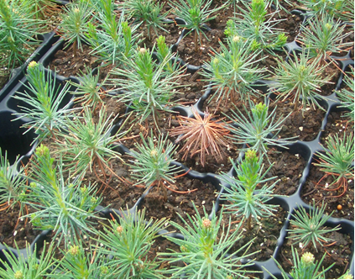 | 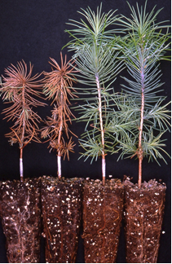
Figure 1 A and B. Typical symptoms of F. circinatum on infected seedlings

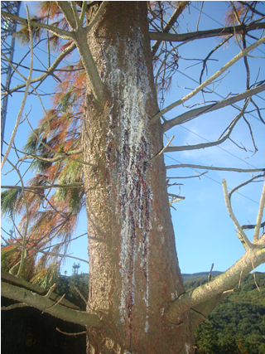 | 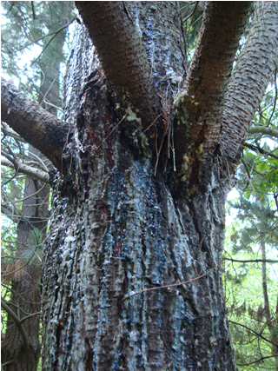

Figure 2 A and B. Canker on the trunk caused by F. circinatum associated with conspicuous and sometimes spectacular resin exudates

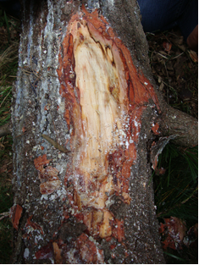

Figure 3. Removal of the bark shows subcortical lesions with brown and resin-impregnated tissues.

Figure 4. Flow diagram for the identification of Fusarium circinatum in a plant sample.

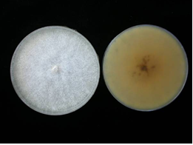

Figure 5. Colony morphology of F. circinatum after 14 days on PDA media.

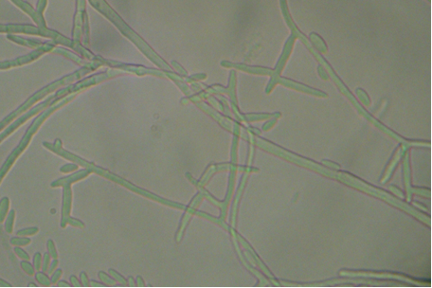 | 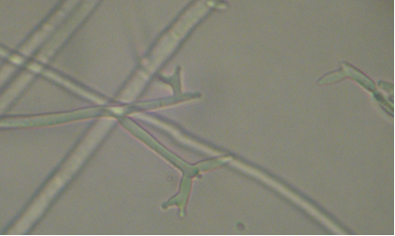
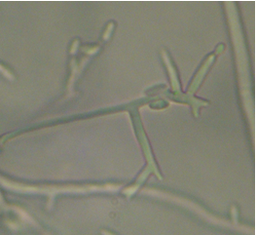 | 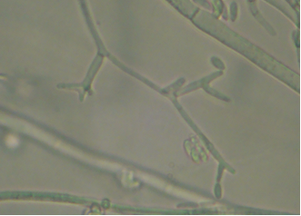

Figure 6. Mono and polyphialidic- conidiophores characteristics of F. circinatum

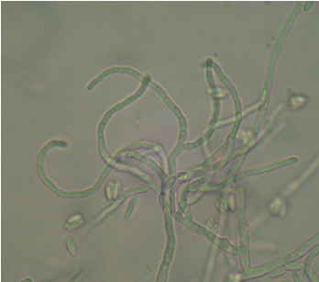 | 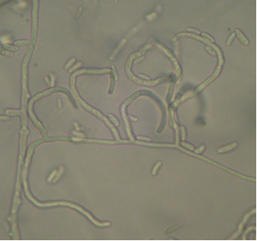
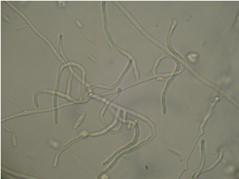 | 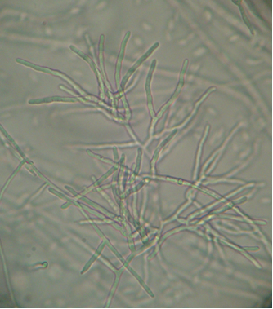
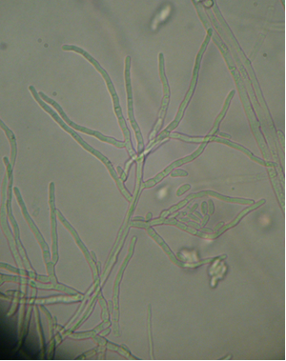

Figures 7a and 7b. The sterile hyphae: coiled (a) ⁄ not distinctively coiled(b) characteristic of F. circinatum.

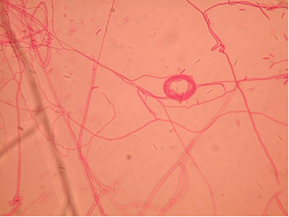

Figures 8. Commonly observed “spiral-wrapped’ hyphae at the surface of the agar, which may be produced by several species of Fusarium.

In this diagnostic protocol, methods (including reference to brand names) are described as published, as these define the original level of sensitivity, specificity and reproducibility achieved. The use of names of chemicals implies no approval of them to the exclusion of others that may also be suitable. Laboratory procedures presented in the protocols may be adjusted to the standards of individual laboratories, provided that they are adequately validated.
See footnote 1.
See footnote 1.
See footnote 1.
See footnote 1.
See footnote 1.
See footnote 1.
See footnote 1.

